**EXPERIMENT -2**

**NAME :SAUMYA SEHGAL**

**SAP ID-500105655**

**R2142220635**

**BATCH :2(N-H)**

**AIM: Working with Docker (Basic Commands)**

**Steps to Complete:**

1. Search a Redis image on DockerHub

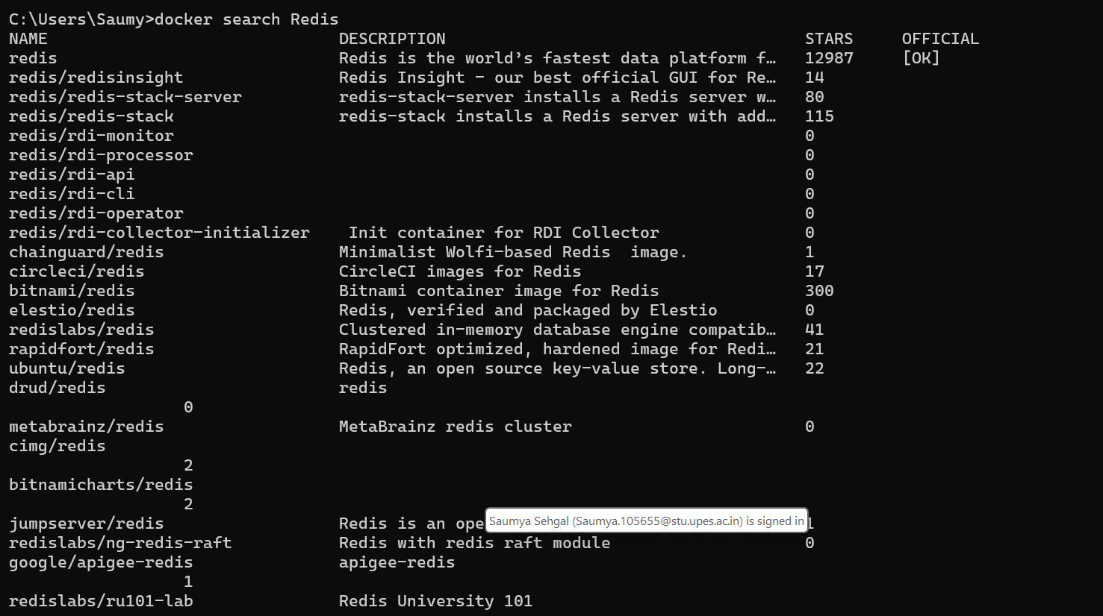

2. Run Docker Container of Redis Image in background

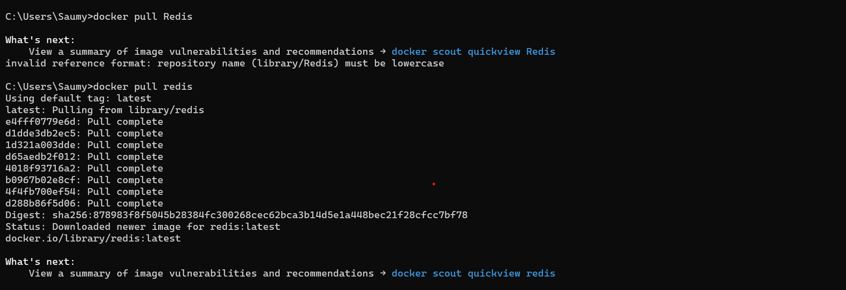



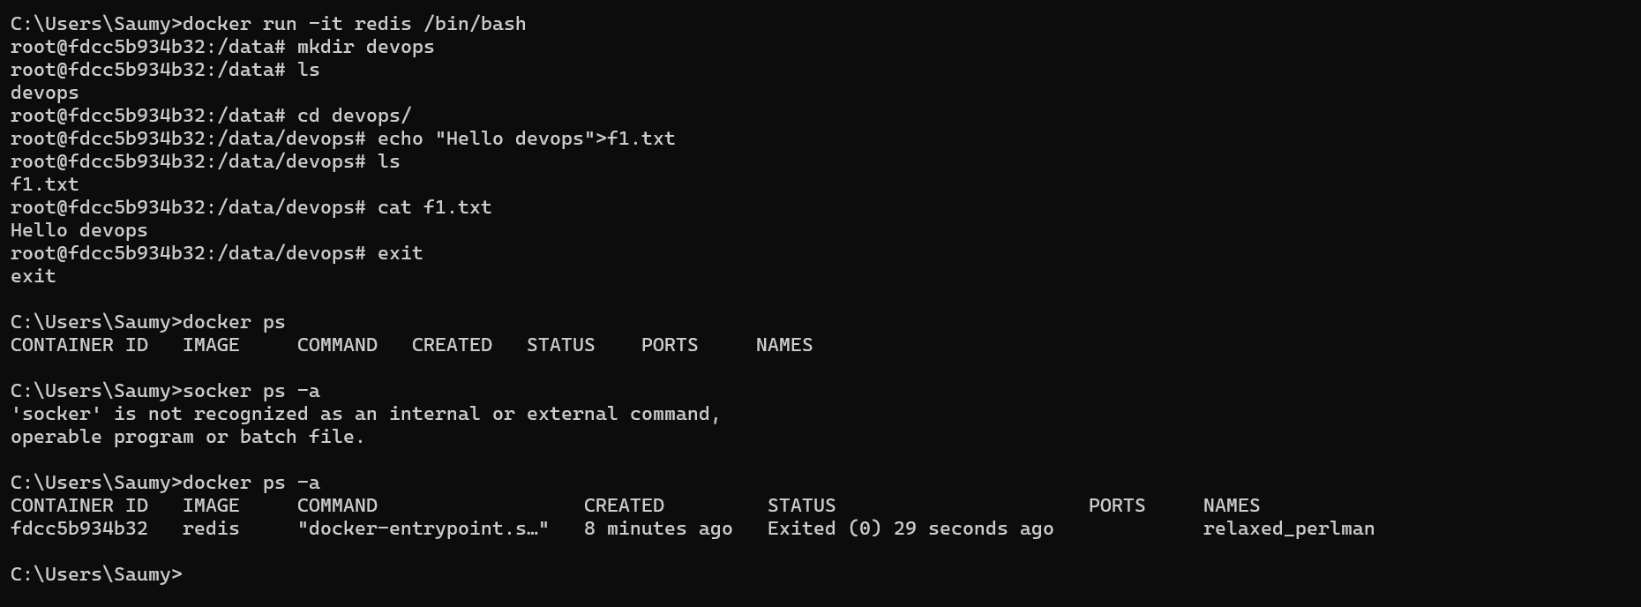

3.Run Docker PS and Docker PS –a

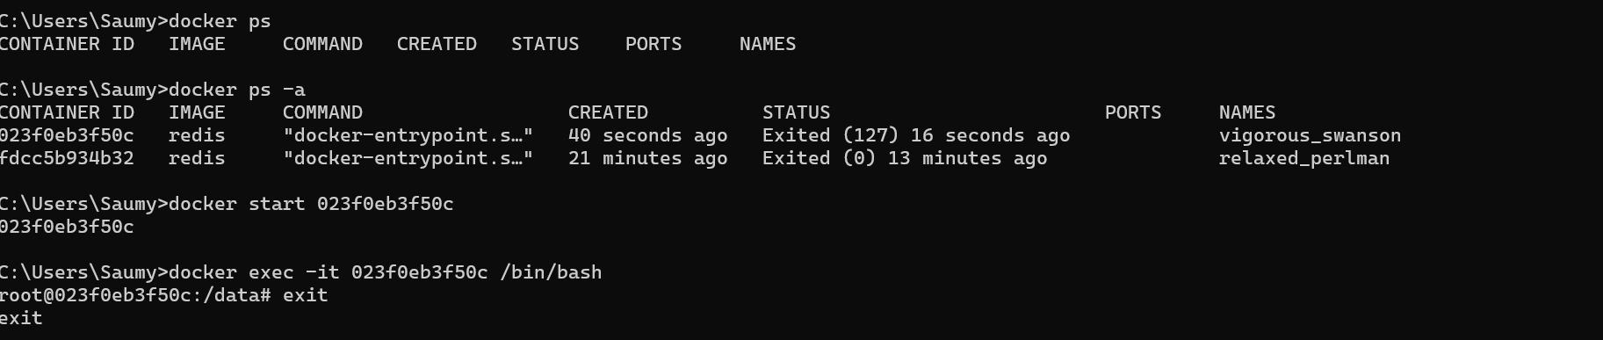

4 .Run Docker Container and take its console

